The Bowen Invites you to a

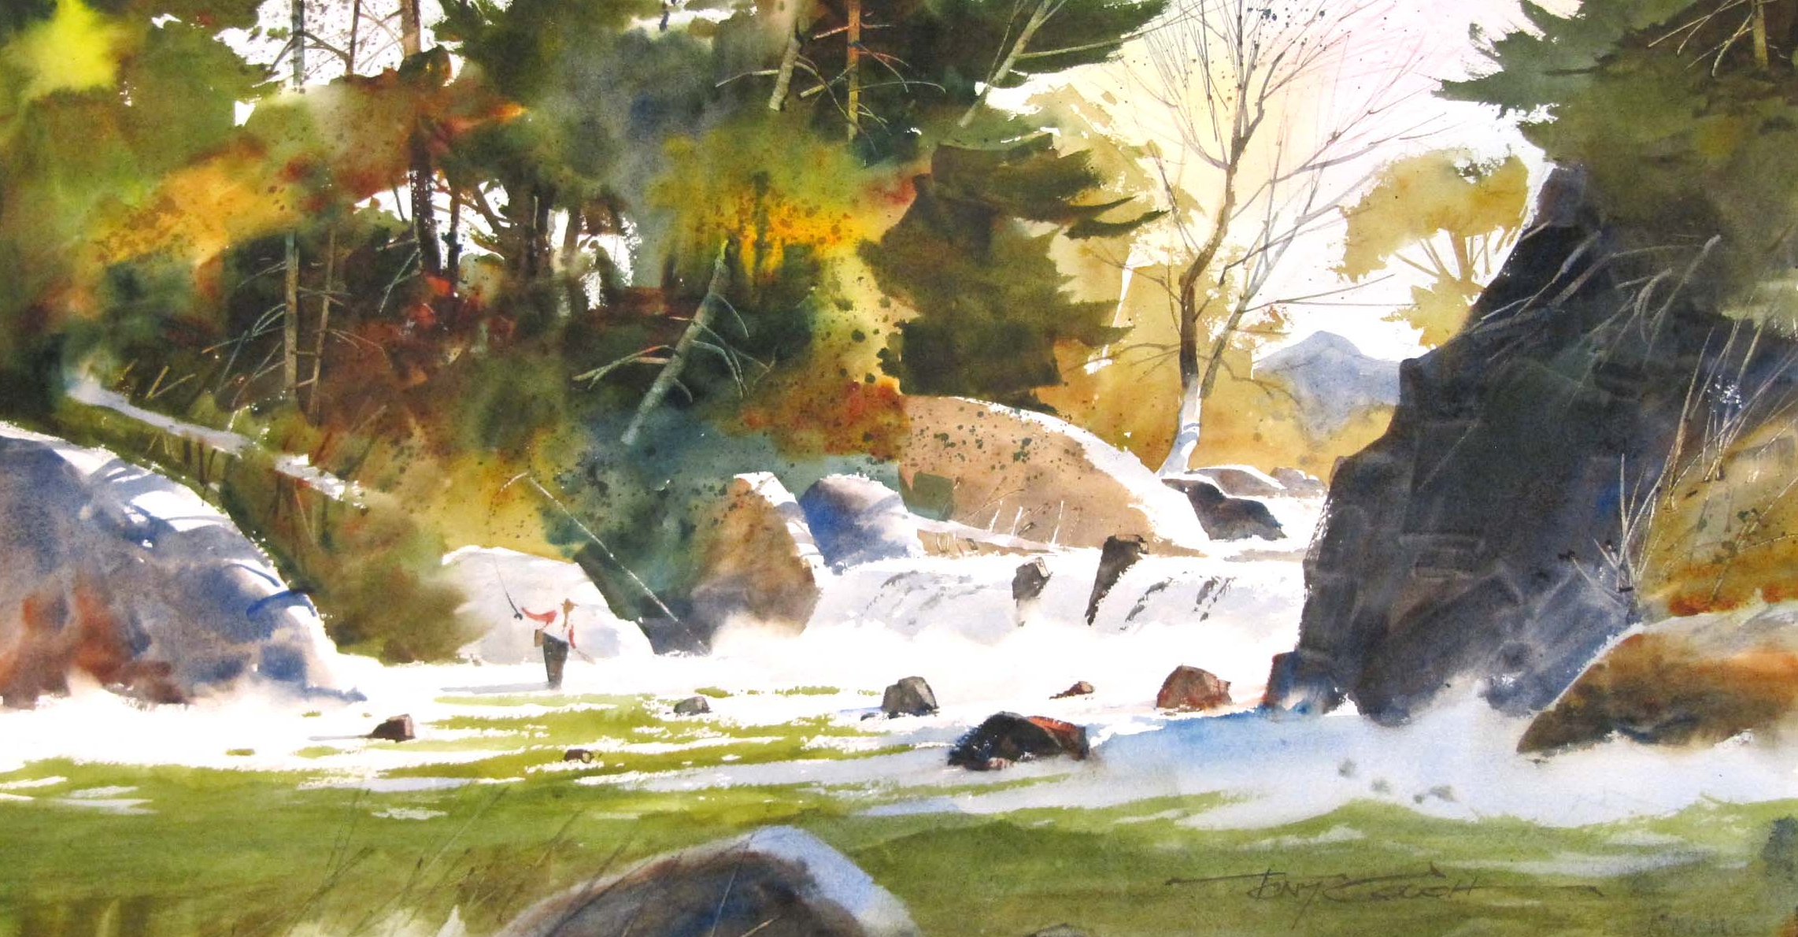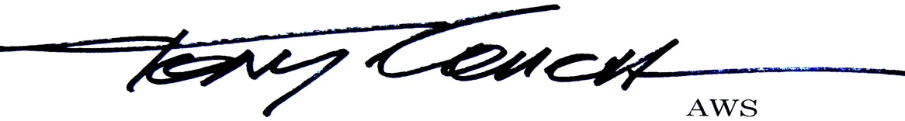
Watercolor Painting Workshop
Monday through Thursday
April 4-7, 2022
This will be a thorough workshop, with Tony doing a full sheet demonstration painting each morning, plenty of time for you to paint in the afternoon, and a critique at the end of the day of all the work done that day, each day.
He’ll unravel much of the “mystery” surrounding design while he shows you how to make your paintings fresh and crisp – and he’ll make color much simpler for you, too. Many students have said they have learned more in one day at one of these workshops than in four years of art school!

Tuition is $395 for Four-Day Workshop

A $200 deposit will hold a spot for you in the workshop, or you may send in the whole amount, if you prefer. The remainder is due March 3. Please make checks payable to Tony Couch fine arts.

No video cameras at the workshop, please. Still cameras OK

CANCELLATIONS: Tuition is fully refundable minus a $25 service fee any time up to March 9. After that date there will be no refunds unless we can sell your spot to another student. If the workshop should cancel: Full tuition refund, but we are not responsible for non-refundable transportation costs.

HOW TO GET THERE:
Dawsonville, GA is a sleepy little mountain town in the foothills of the N Georgia mountains, located About 55 miles north of Atlanta and just west of GA-400

If you’re flying:
Atlanta (ATL) is the nearest airport, just 90 minutes away, and is served by all major airlines from major cities. Out of the airport, head north on I-85 through Atlanta and pickup GA 400 north of the downtown area. In 42 miles, exit GA 400 westbound on GA 53, and in 6 miles take a sharp right onto GA9N. Bowen Art Center will be on your right in about ¼ mile.

If you’re driving:
From Atlanta: pickup GA 400 northbound. 36 miles N of I-285, exit GA 400 westbound onto GA 53, and in 6 miles take a sharp right onto GA9N. Bowen Art Center will be on your right in about ¼ mile.
From Anywhere E or NE of Atlanta: On I-85 take exit 137 westbound onto GA-11/US-129 to Gainesville, then GA-53 to Dawsonville, taking a sharp right onto GA-9N. Bowen Art Center will be on your right in about ¼ mile.
From Anywhere W or NW of Atlanta: On I-75 take exit 312 eastbound onto GA-53 to Dawsonville, then around the old courthouse in the middle of town and out the other side onto GA-9N. Bowen Art Center will be on your right in about 1/2 mile.
If you’re using a GPS:
Type the address 334 Highway 9N, Dawsonville GA 30534. Note: spell out “highway” 9 (don’t abbreviate HWY) or it won’t find the right place.
LODGING:
Village Inn (706) 216-4410, Super 8 (706) 216-6801, & Comfort Inn (706) 216-1900 are within 6 miles, Days Inn (706) 864-2338 & Holiday Inn (706) 867-7777 are within 11. Rates range between $68 and $85/night. For the list and specifics, go to www.trivago.com or www.hotels.com and type in “Dawsonville, GA.”

Questions?
Call Ginny Greenwood at (706) 216-2787 or email director@bowenarts.org
Or Belinda Couch (770) 630-4338 or tonycouchart@yahoo.com

You’ll be sent a recommended supply list when you send the coupon, below.
clip clip clip clip clip clip
Please reserve a spot for me at the Tony Couch watercolor workshop Dawsonville, GA April 4-7, 2022. Enclosed is my check or charge number for $____. Please make checks payable to Tony Couch Fine Art, Inc..

Name___________________________________________________________________

Street Address____________________________________________________________

City & State______________________________________________________________

Phone__________________________Email____________________________________

VISA, MC or AmEx# is _______-_______-_______-_______Exp date ____/____Sec Code*_________
*Security code is the 3-digit number on the back of most cards; 4 digit on front of AmEx cards

Please clip and send to:
Belinda Couch / 36 Archies Way / Cleveland, GA 30528
Or, if charging, you can fax this form to (678) 513-6659

