Erica Jones
DCN Staff
Published: Aug 25, 2021, 11:43 AM

The inside of the Bowen Center for the Arts bustled with activity. Dozens of women sat around tables, eating brunch and pastries off of floral paper plates, talking and laughing with one another.
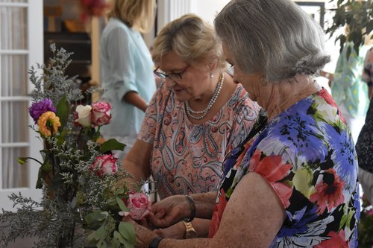
“Brunch and Bouquets” attendees try their hand at making their own floral arrangements during the event. - photo by Erica Jones

We were attending a floral arranging class called “Brunch and Bouquets,” hosted at the Bowen and taught by Bowen board member and interior designer Tracey Smith.
As attendees finished up eating brunch, Smith began circulating the room, pointing out and discussing the different floral bouquets adorning each table. She described the thought that went into arranging each one, from choosing complimentary colors to picking out the perfect vase to place the flowers in.
Smith returned to the front of the room, where several empty vases and buckets of different flowers and greenery stood. We watched as she described how to start building the perfect floral bouquet, adding in different pieces to a vase as she talked.
Gradually, the arrangement started taking shape, changing from an empty vase to a floral arrangement with greenery and brightly colored flowers arranged in a large curved shape.
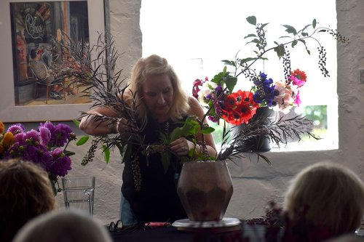
Smith talks through and demonstrates how to make the perfect floral arrangement. - photo by Erica Jones

